Instructions on how to take self vaginal swabs

Please read all instructions before collecting specimens. If you have any questions about this procedure, please ask your doctor or nurse
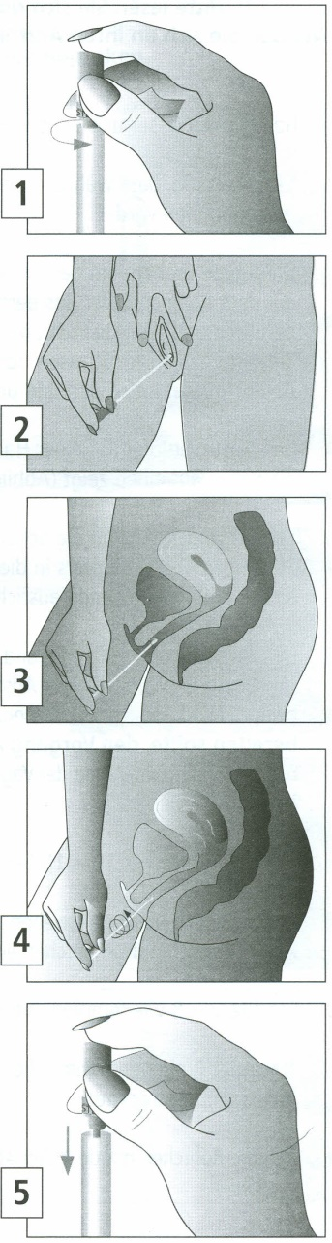
- Wash hands with soap and water. Rinse and dry.

- It is important to maintain a comfortable balance during the collection procedure.

- Twist the cap to break the seal (Figure 1). Pull the cap with attached swab off the tube. Do not touch the soft tip or lay the swab down. If you touch or drop the swab tip or the swab is laid down, discard the swab and request a new vaginal swab.

- Hold the swab by the cap with one hand so the swab tip is pointing toward you (Figure 2).

- With your other hand, gently spread the skin outside the vagina. Insert the tip of the swab into the vaginal opening (Figure 2). Point the tip toward your lower back and relax your muscles.

- Gently slide the swab no more than two inches into the vagina (Figure 3). If the swab does not slide easily, gently rotate the swab as you push. If it is still difficult, do not attempt to continue. Make sure the swab touches the walls of the vagina so that moisture is absorbed by the swab.

- Rotate the swab for 10 -15 seconds (Figure 4).

- Withdraw the swab without touching the skin. Place the swab in the tube and cap securely (Figure 5).

- Repeat steps 2-8 if a second swab is to be collected.

- After collection, wash hands with soap and water, rinse, and dry.

- Return tube(s) with swab(s) as instructed.

- Please place the swabs in the specimen bag and seal at the top.

- Return the sealed bag via the specimen drop off point at reception.

